Week-4

Semi-supervised Learning
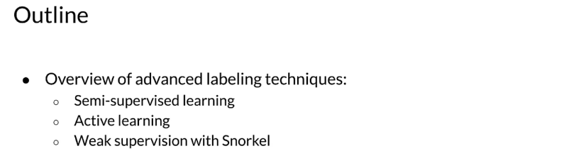

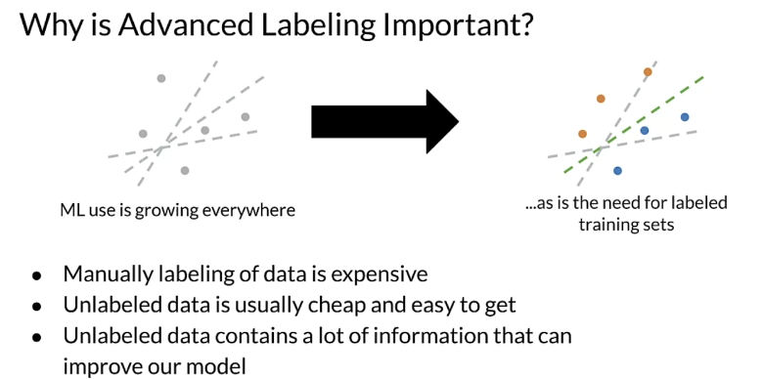
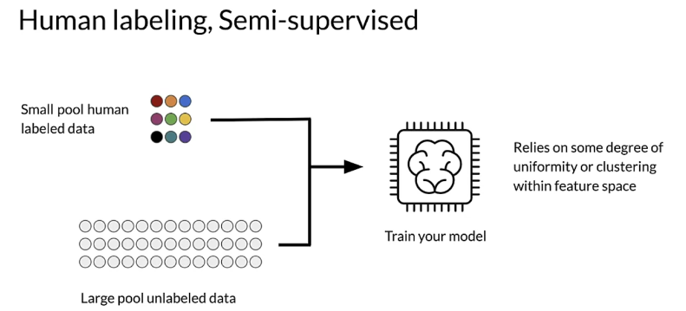

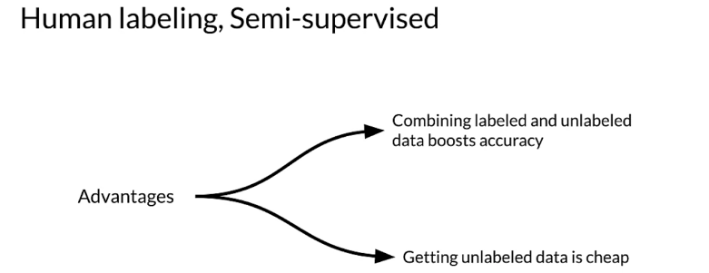
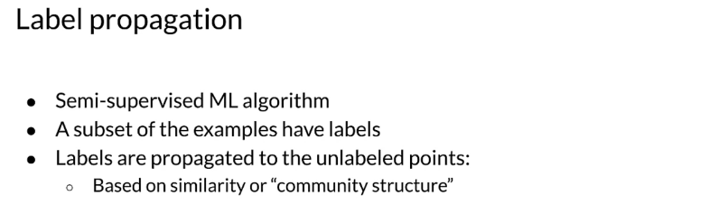

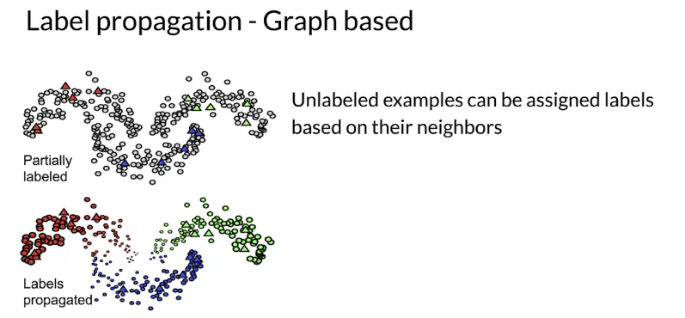

Active Learning
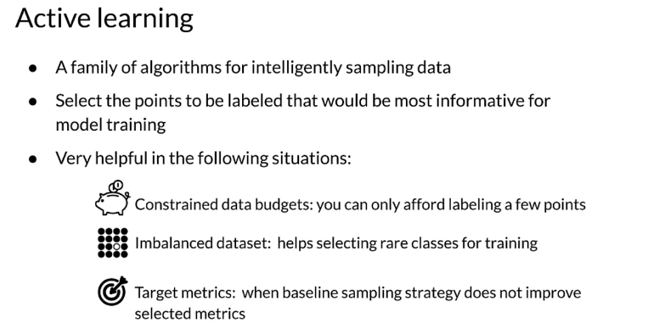

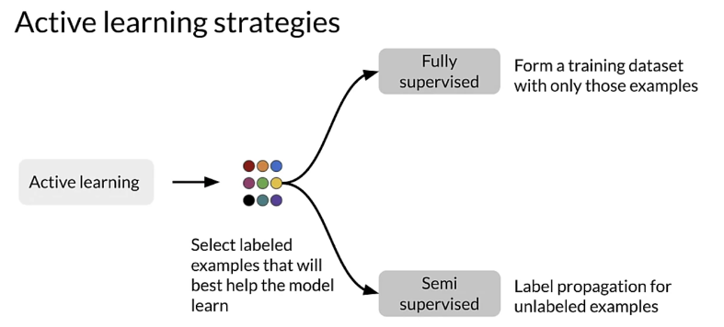

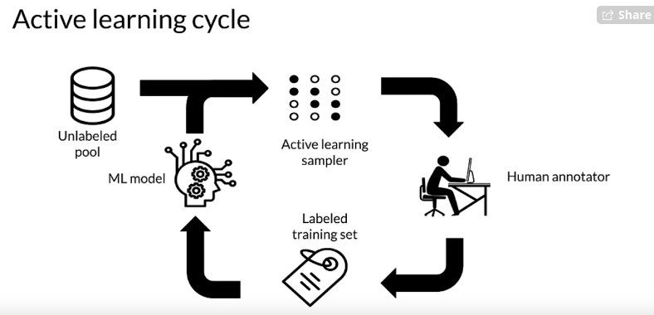
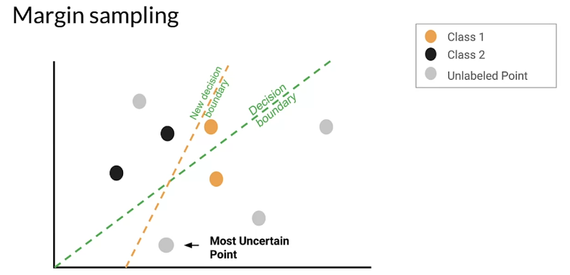

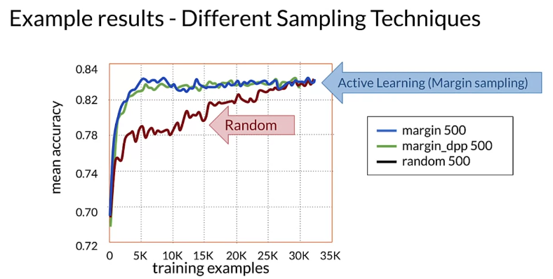

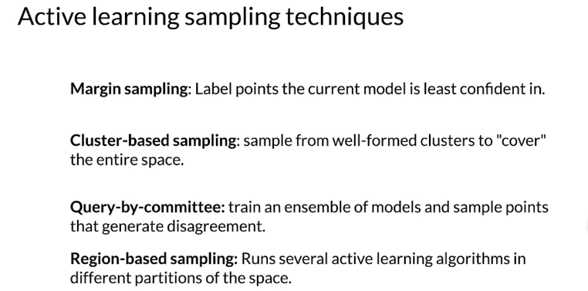

Weak Supervision
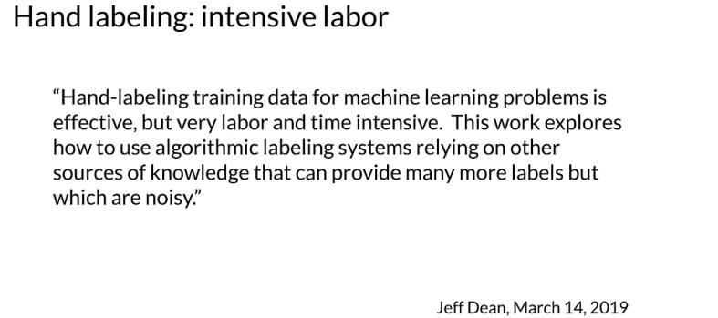
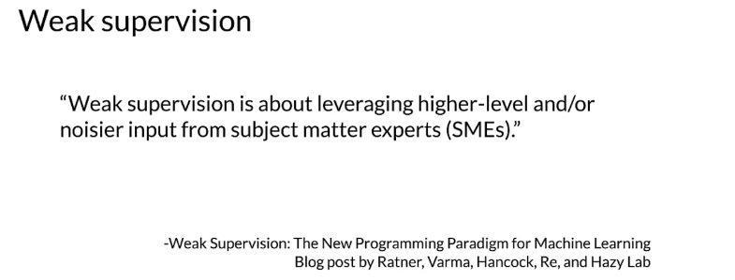
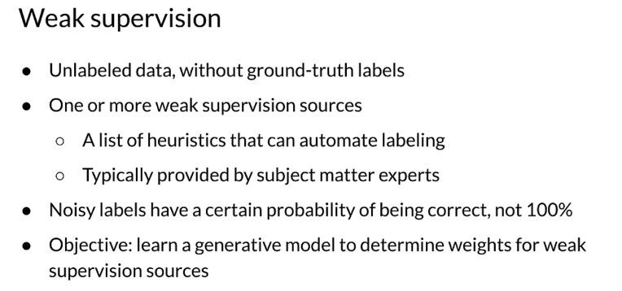
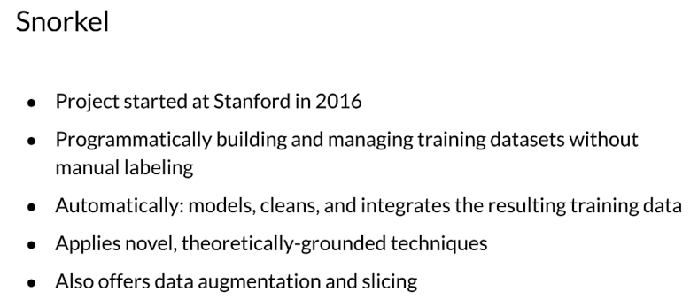

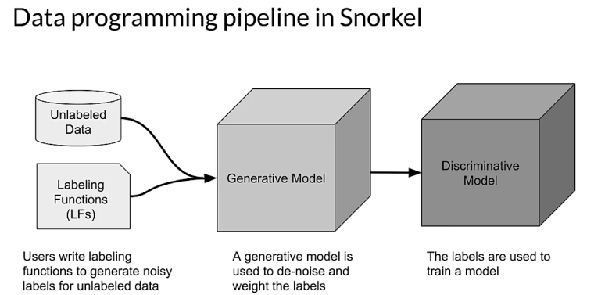
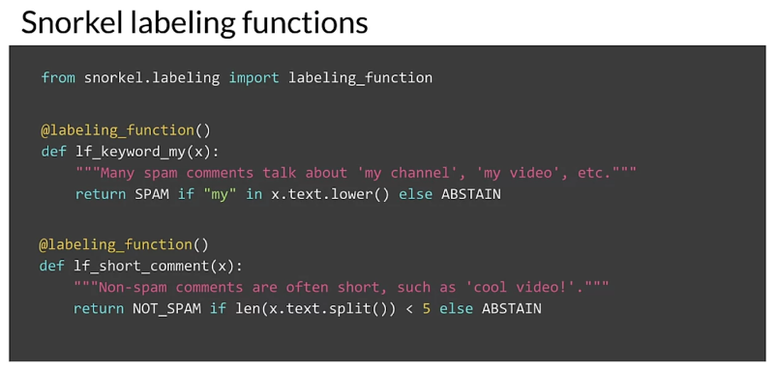
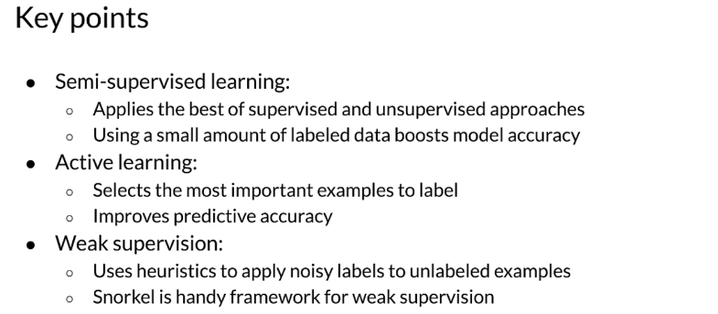

Data Augmentation
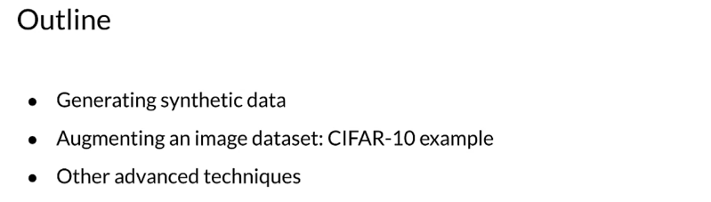

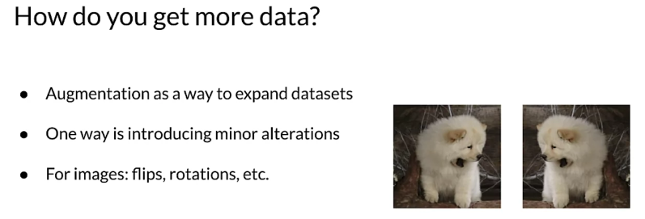
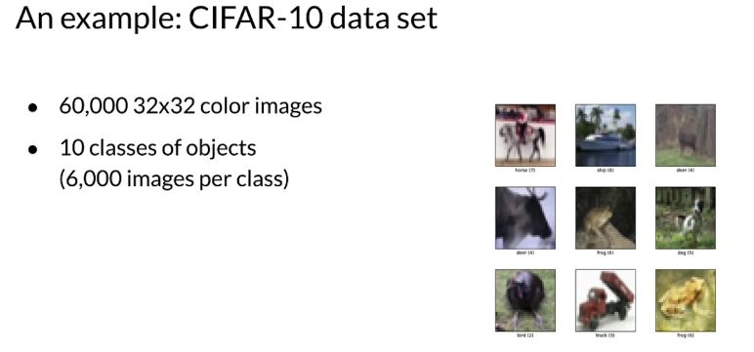

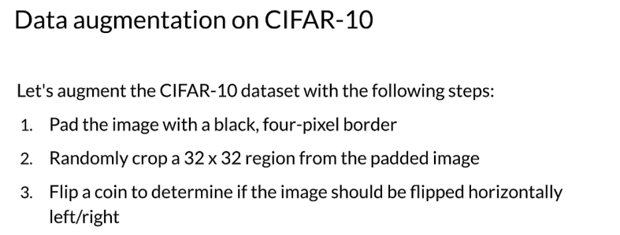
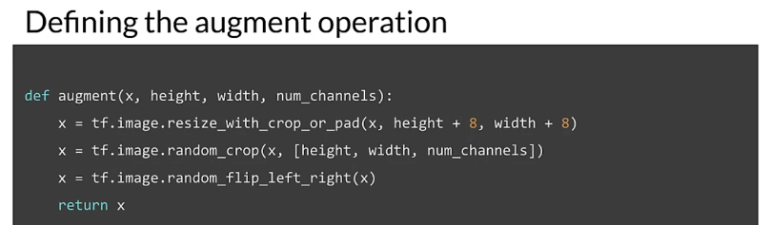
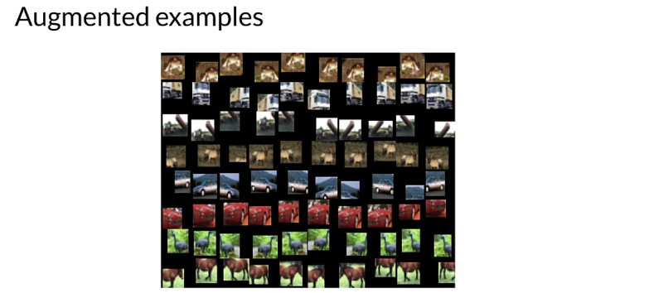
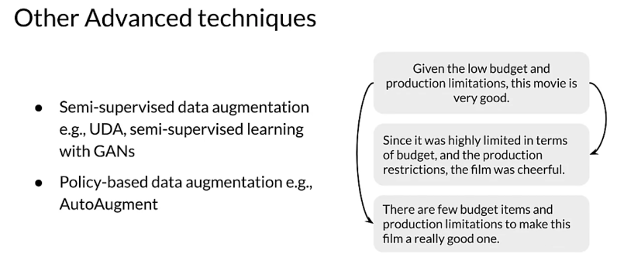
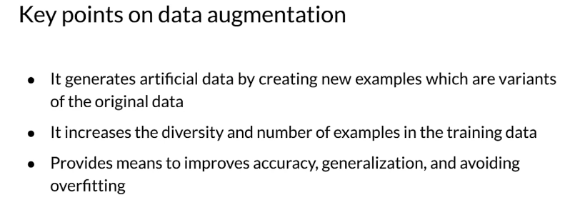

Time Series
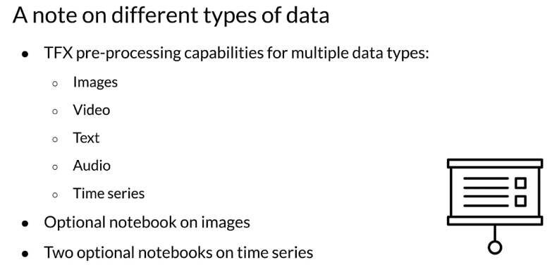
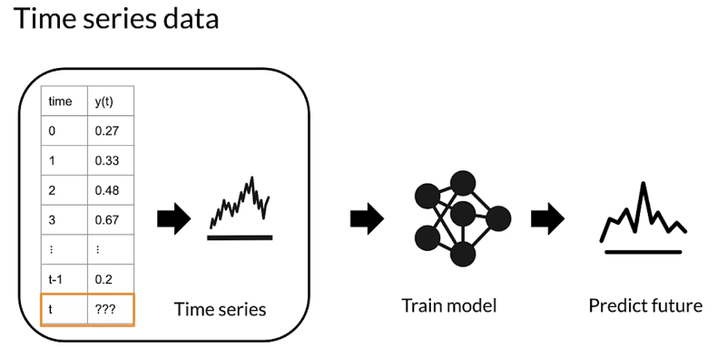
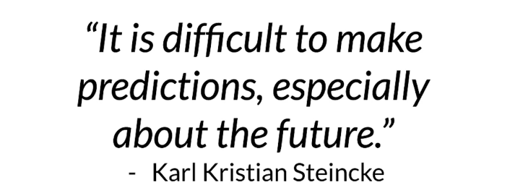
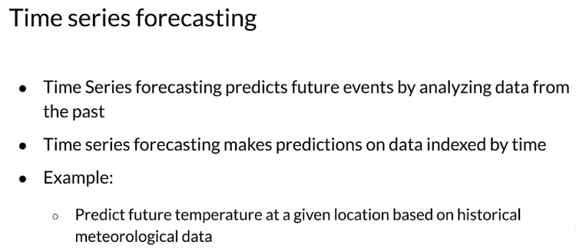

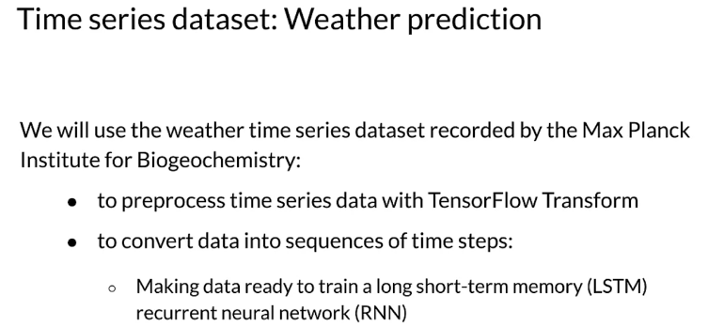
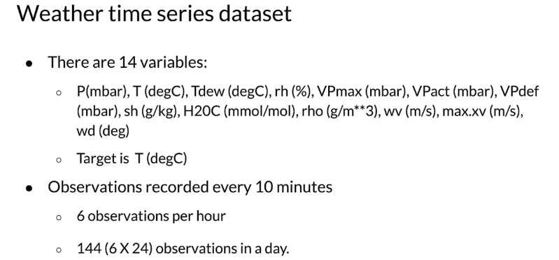
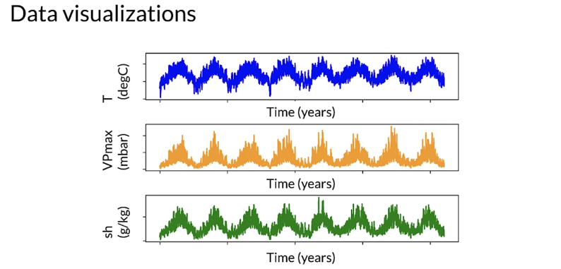

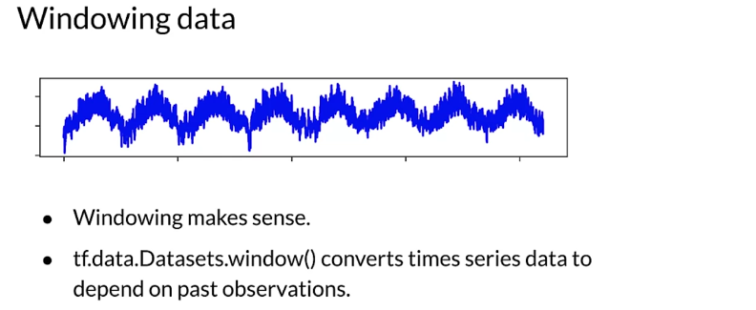
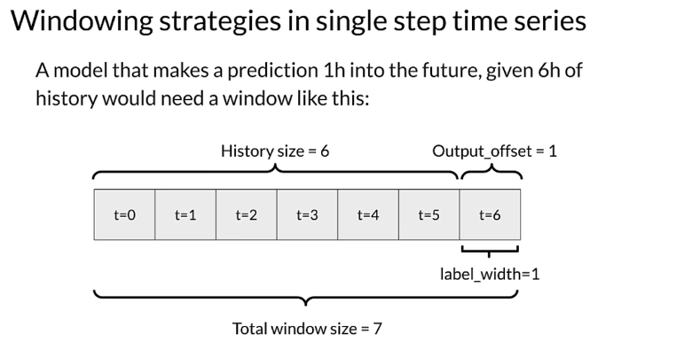
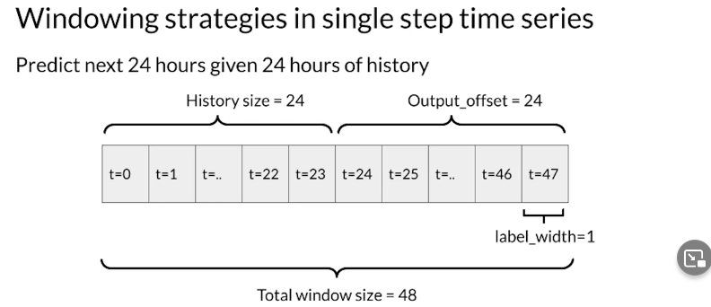
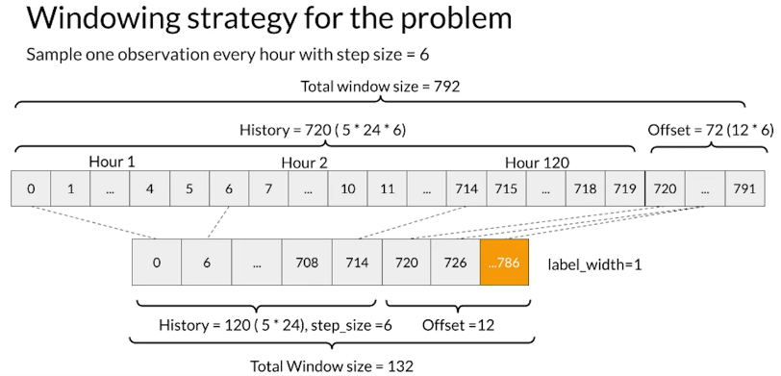
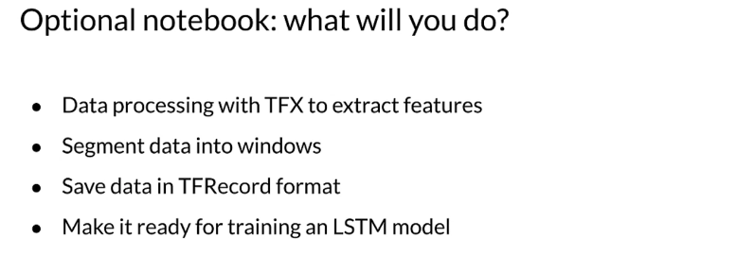

Sensors and Signals

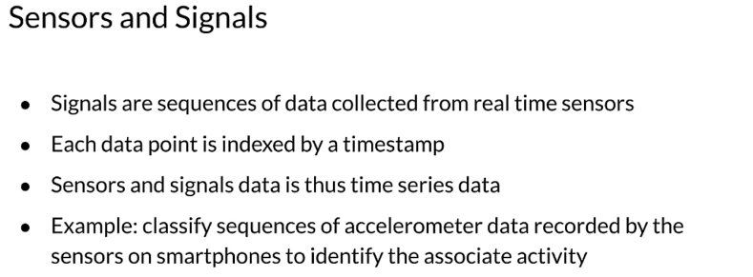
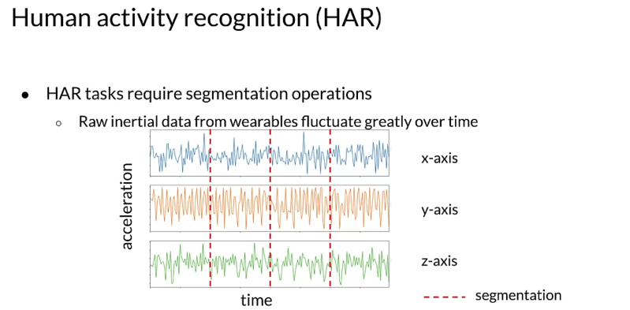
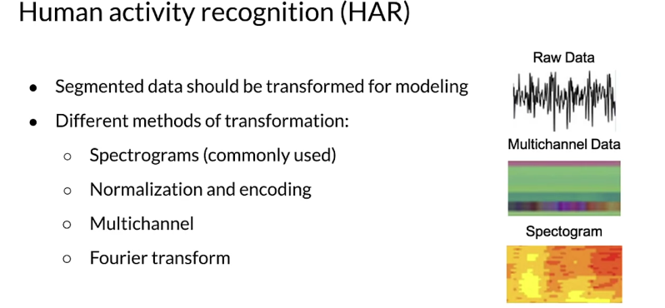
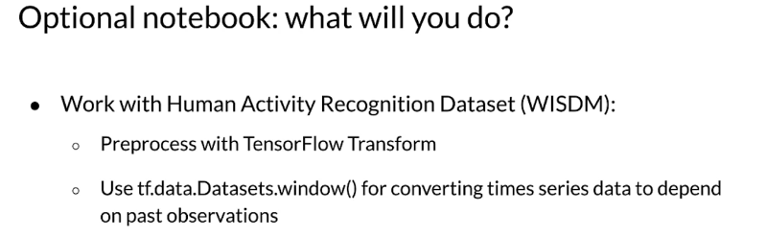

Course 2 Optional References

Machine Learning Data Lifecycle in Production
This is a compilation of resources including URLs and papers appearing in lecture videos. If you wish to dive more deeply into the topics covered this week, feel free to check out these optional references.

Overall resources:
Konstantinos, Katsiapis, Karmarkar, A., Altay, A., Zaks, A., Polyzotis, N., … Li, Z. (2020). Towards ML Engineering: A brief history of TensorFlow Extended (TFX). http://arxiv.org/abs/2010.02013
Paleyes, A., Urma, R.-G., & Lawrence, N. D. (2020). Challenges in deploying machine learning: A survey of case studies. http://arxiv.org/abs/2011.09926

Week 1: Collecting, Labeling and Validating Data
ML code fraction:
MLops
Data 1st class citizen
Runners app
Rules of ML
Bias in datasets
Logstash
Fluentd
Google Cloud Logging
AWS ElasticSearch
Azure Monitor
TFDV
Chebyshev distance
Sculley, D., Holt, G., Golovin, D., Davydov, E., & Phillips, T. (n.d.). Hidden technical debt in machine learning systems. Retrieved April 28, 2021, from Nips.cc https://papers.nips.cc/paper/2015/file/86df7dcfd896fcaf2674f757a2463eba-Paper.pdf

Week 2: Feature Engineering, Transformation and Selection
Mapping raw data into feature
Feature engineering techniques
Facets
Embedding projector
Encoding features
TFX:
- https://www.tensorflow.org/tfx/guide#tfx_pipelines
- https://ai.googleblog.com/2017/02/preprocessing-for-machine-learning-with.html
Breast Cancer Dataset

Week 3: Data Journey and Data Storage
Data Versioning:
- https://dvc.org/
- https://git-lfs.github.com/
ML Metadata:
- https://www.tensorflow.org/tfx/guide/mlmd#data_model
- https://www.tensorflow.org/tfx/guide/understanding_custom_components
Chicago taxi trips data set:
- https://data.cityofchicago.org/Transportation/Taxi-Trips/wrvz-psew/data
- https://archive.ics.uci.edu/ml/datasets/covertype
Feast:
- https://cloud.google.com/blog/products/ai-machine-learning/introducing-feast-an-open-source-feature-store-for-machine-learning
- https://github.com/feast-dev/feast
- https://blog.gojekengineering.com/feast-bridging-ml-models-and-data-efd06b7d1644

Week 4: Advanced Labeling, Augmentation and Data Preprocessing
Hand Labeling
Weak supervision
Snorkel
How do you get more data?
Advanced Techniques
Images in tensorflow
CIFAR-10
- https://www.cs.toronto.edu/~kriz/cifar.html
- https://www.tensorflow.org/datasets/catalog/cifar10
Weather dataset
Human Activity Recognition
Papers
Label Propagation:
Iscen, A., Tolias, G., Avrithis, Y., & Chum, O. (2019). Label propagation for deep semi-supervised learning. https://arxiv.org/pdf/1904.04717.pdf
Slide 13 active learning:
Source: Original slides by Yale Cong

